Chapter 1
Introduction

1.1 Project Description

Miltary Management System, project is a complete online solution for public who want to obtain the information about the Defence. Military Management System project is developed using HTML,CSS and SQL server. This project is developed for the users who want to gather the information about Armed Force. This website is very helpful for Admin to manage the details of the Soldiers,Doctors,Transportation and Weapons. This project report gives overall system information of the system. Here you can get DFD and ER diagram of the Military management system. In this project report we have also explained the different module of Military Management system. This project report can be used for system design, system development and system testing. It provides information for understanding the system.

1.2 Objectives of the project

The objective of developing the Military management system is to add the soldiers and doctors and weapons and transportation and we can also manage these modules. The general public can view the details of our military management system like the Chief commanders , Wars .The admin can also manages the different modules and the soldiers can also view their profile to see their basic information about their weapons .

Chapter 2
Requirement and analysis

2.1 Existing System

- The current existing system is not efficient and even out dated.
- The necessary information can not be accessed in single platform.
- Most of the work is done through paper work , which makes it hard to maintain and preserve it for a long period of time.

2.2 Proposed System

Advantages of the Proposed System
- Various fields of the defence can be obtained in a single nplatform which makes it easier to maintain.
- It digitialize the maintainance of the database and hence reduce the man power and makes the system more efficient.
- Here the soldiers can view their profile easily instead of asking the other officials.
- Even the doctors can also view their details inorder to know which soldier has been assigned for the treatment.

2.3 Hardware Requirements
Software requirements

1. Operating system
Windows 7/8/10/11
2. Frontend: HTML 5 and CSS 3
3. PHP
4. Backend: MY SQL
Hardware requirements
1. RAM: 3 – 4 GB
2. Processor: Intel i3, AMD Ryzen 3 and Apple M1 chipset
3. Space required: 15 – 20 GB

2.4 Software Requirements

Operating system: Linux/Windows
Tools: mysql, browser, apache server, php scripting

2.5 Analysis

2.5.1 Use case diagram

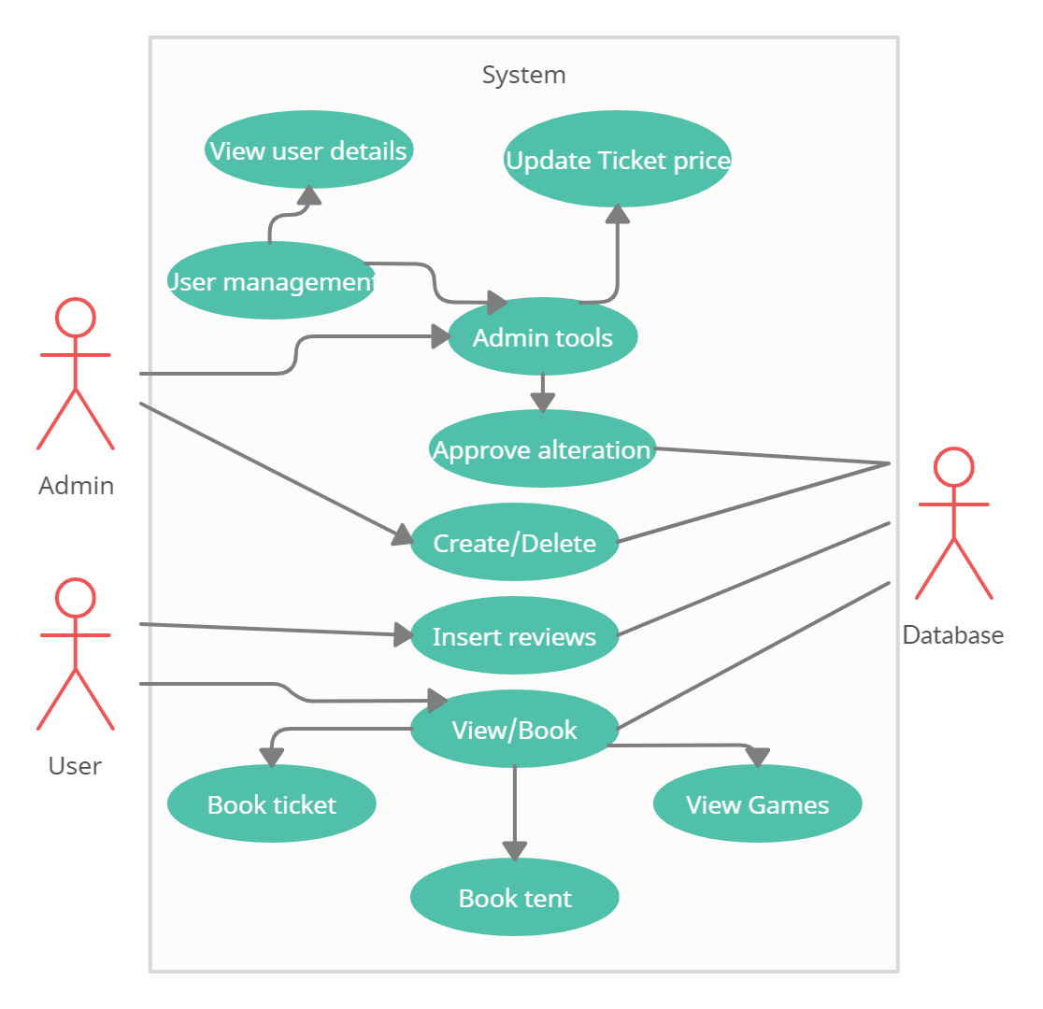
Advertising management

Fig:2.1 Use case Diagram for Online advertising Management

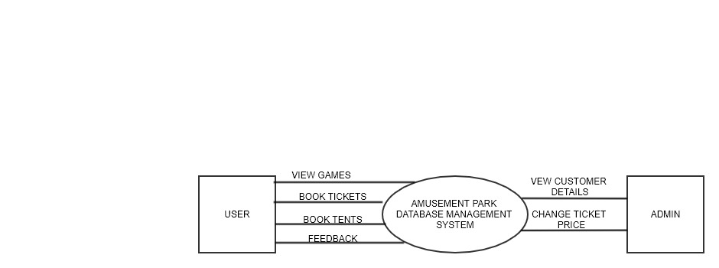
2.5.2 Data flow Diagram

Chapter 3
System Design

3.1 Entity Relation Diagram

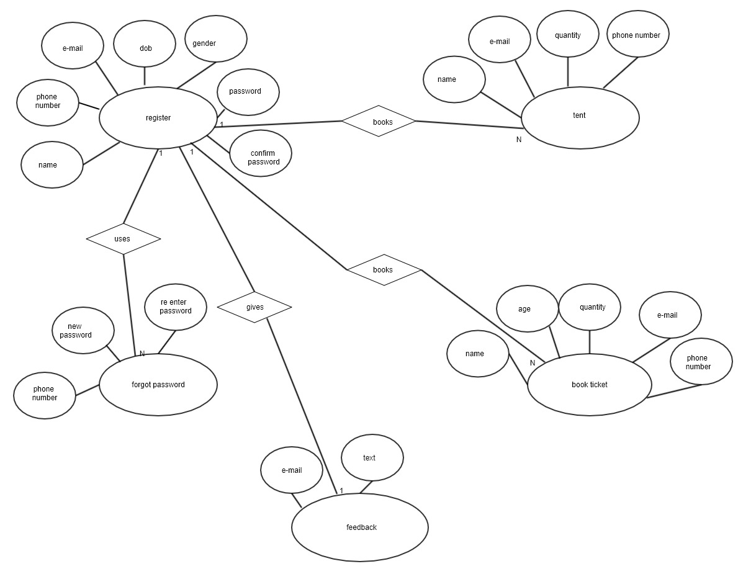

Fig:3.1 Database Entity Relation Diagram

ER mapping to physical schema-diagram
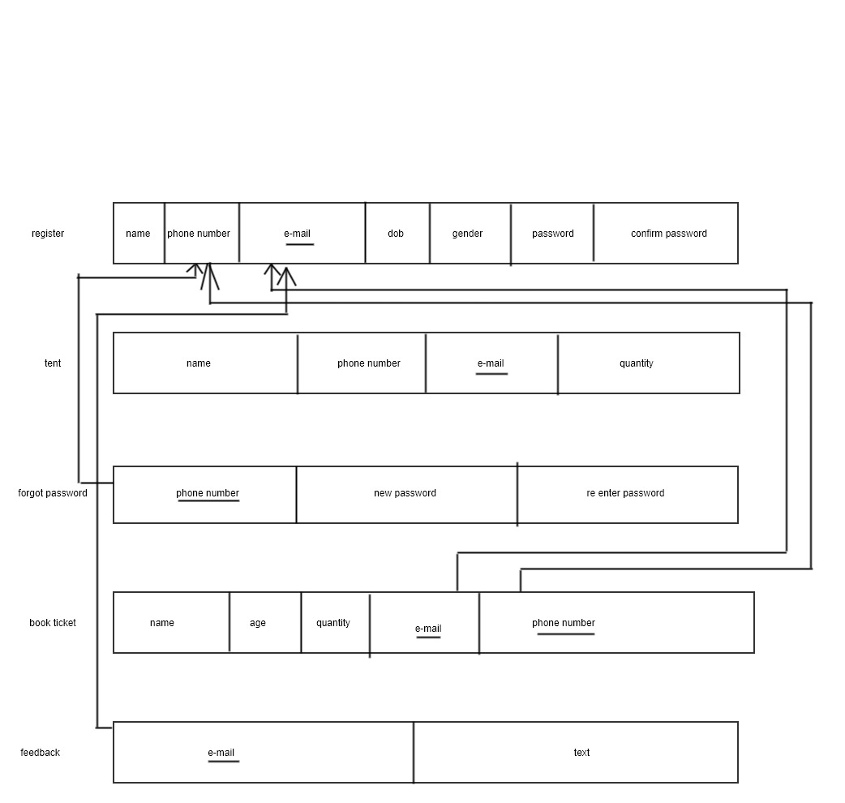

3.2 Database techniques
3.2.1 MYSql Server

SQL (Structured Query Language) is a domain-specific language used in programming and designed for managing data held in a relational database management system (RDBMS), or for stream processing in a relational data stream management system (RDSMS). In comparison to older read/write APIs like ISAM or VSAM, SQL offers two main advantages: first, it introduced the concept of accessing many records with one single command; and second, it eliminates the need to specify how to reach a record, e.g. with or without an index.
Originally based upon relational algebra and tuple relational calculus, SQL consists of a data definition language, data manipulation language, and data control language. The scope of SQL includes data insert, query, update and delete, schema creation and modification, and data access control. Although SQL is often described as, and to a great extent is, a declarative language (4GL), it also includes procedural elements. SQL was initially developed at IBM by Donald D. Chamberlin and Raymond F. Boyce in the early 1970s. This version, initially called SEQUEL (Structured English Query Language), was designed to manipulate and retrieve data stored in IBM's original quasirelational database management system, System R, which a group at IBM San Jose Research Laboratory had developed during the 1970s.

The SQL language is subdivided into several language elements, including:

• Clauses, which are constituent components of statements and queries. (In some cases, these are optional.)
• Expressions, which can produce either scalar values, or tables consisting of columns and rows of data
• Predicates, which specify conditions that can be evaluated to SQL three-valued logic (3VL)(true/false/unknown) or Boolean truth values and are used to limit the effects of statements and queries, or to change program flow.
• Queries, which retrieve the data based on specific criteria. This is an important element of SQL.
• Statements, which ma diagnostics. y have a persistent effect on schemata and data, or may control transactions, program flow, connections, sessions, or

3.2.2 Normalization

Normalization is the process of efficiently organizing data in a database. There are two goals of the normalization process: eliminating redundant data (for example, storing the same data in more than one table) and ensuring data dependencies make sense (only storing related data in a table). Both of these are worthy goals as they reduce the amount of space a database consumes and ensure that data is logically stored. There are several benefits for using Normalization in Database.

Benefits:

• Eliminate data redundancy
• Improve performance
• Query optimization
• Faster update due to less number of columns in one table Index improvement

There are different types of normalizations form available in the database.

1.First Normal Form (1NF):
First normal form (1NF) sets the very basic rules for an organized database:
• Eliminate duplicative columns from the same table.
• Create separate tables for each group of related data and identify each row with unique column or set of columns (the primary key).
• Remove repetitive groups
• Create Primary Key
Before we proceed let's understand a few things -- A KEY is a value used to identify a record in a table uniquely. A KEY could be a single column or combination of multiple columns Note: Columns in a table that are NOT used to identify a record uniquely are called non-key columns.
Primary Key


2.Second Normal Form(2NF):
Second normal form(2NF) further address the concept of rmoving duplicative data:
• Meet all the requirements of the first Normal form.
• Remove the subset of data that apply to multiple rows of a table and place them in separate tables.

3.Third Normal Form (3NF):
Third normal form (3NF) goes one large step further:
• Meet all the requirements of the second normal form.
• Remove columns that is not dependent upon the primary key.

4. Fourth Normal Form (4NF):
Finally, fourth normal form (4NF) has one additional requirement:
• Meet all the requirements of the third normal form.
• A relation is in 4NF if it has no multi-valued dependencies.

If PK is composed of multiple columns then all non-key attributes should be derived from FULL PK only. If some non-key attribute can be derived from partial PK then remove it. The 4NF also known as BCNF NF.
Chapter 4
Implementation and Results
4.1 Algorithms

Index:

1. Display options of doctor login,soldier login and admin login.
2. Link corresponding pages to them.

Admin login:

- Connect to database.
- Read admin name and password using post method.
- If the entered values are correct then,
- Redirect to admin operation.
- Else show error message.

Admin operations:

1. Show admin operations such as,
2.View soldiers,doctors,transportation,weapon details.

4.2 Results

4.2.1 Snapshots

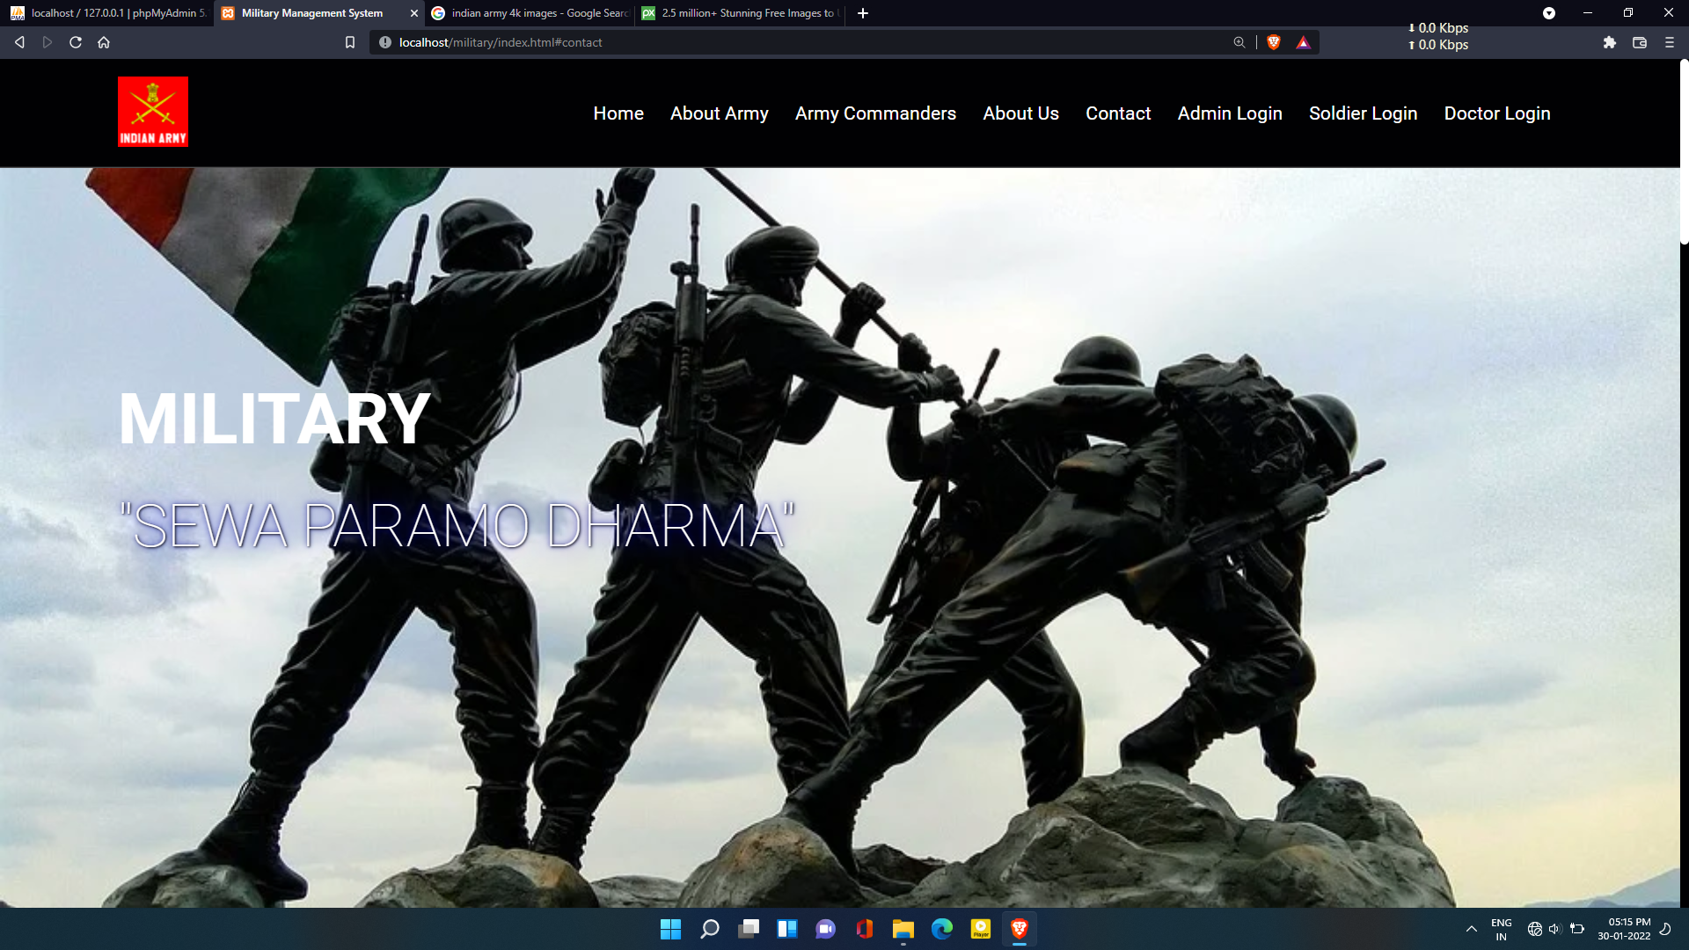
Fig.4.1 Index page

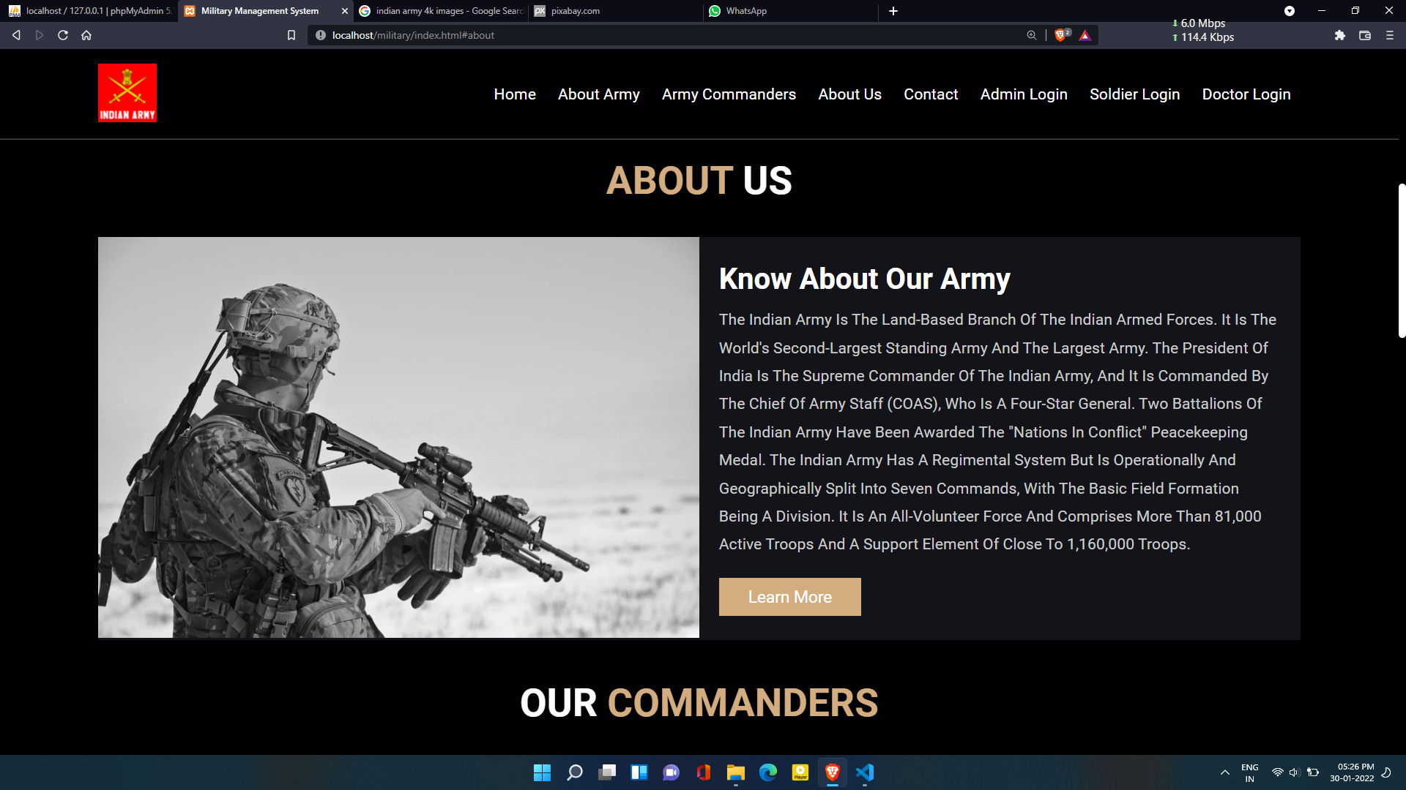
Fig 4.2: About Us

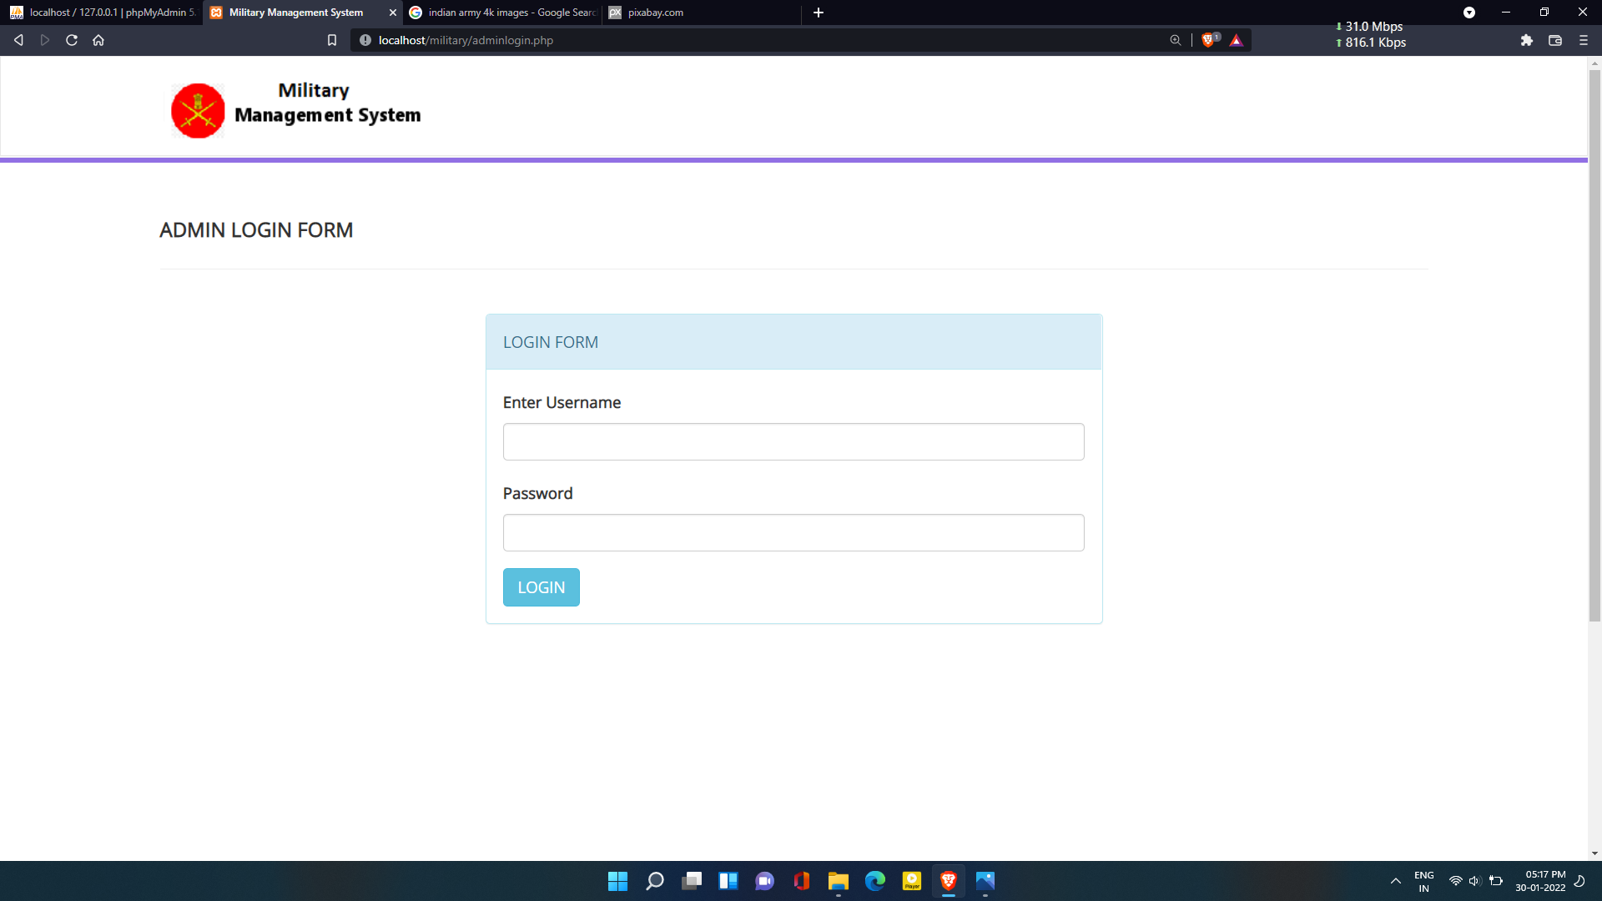

Fig 4.3: Admin Login Page

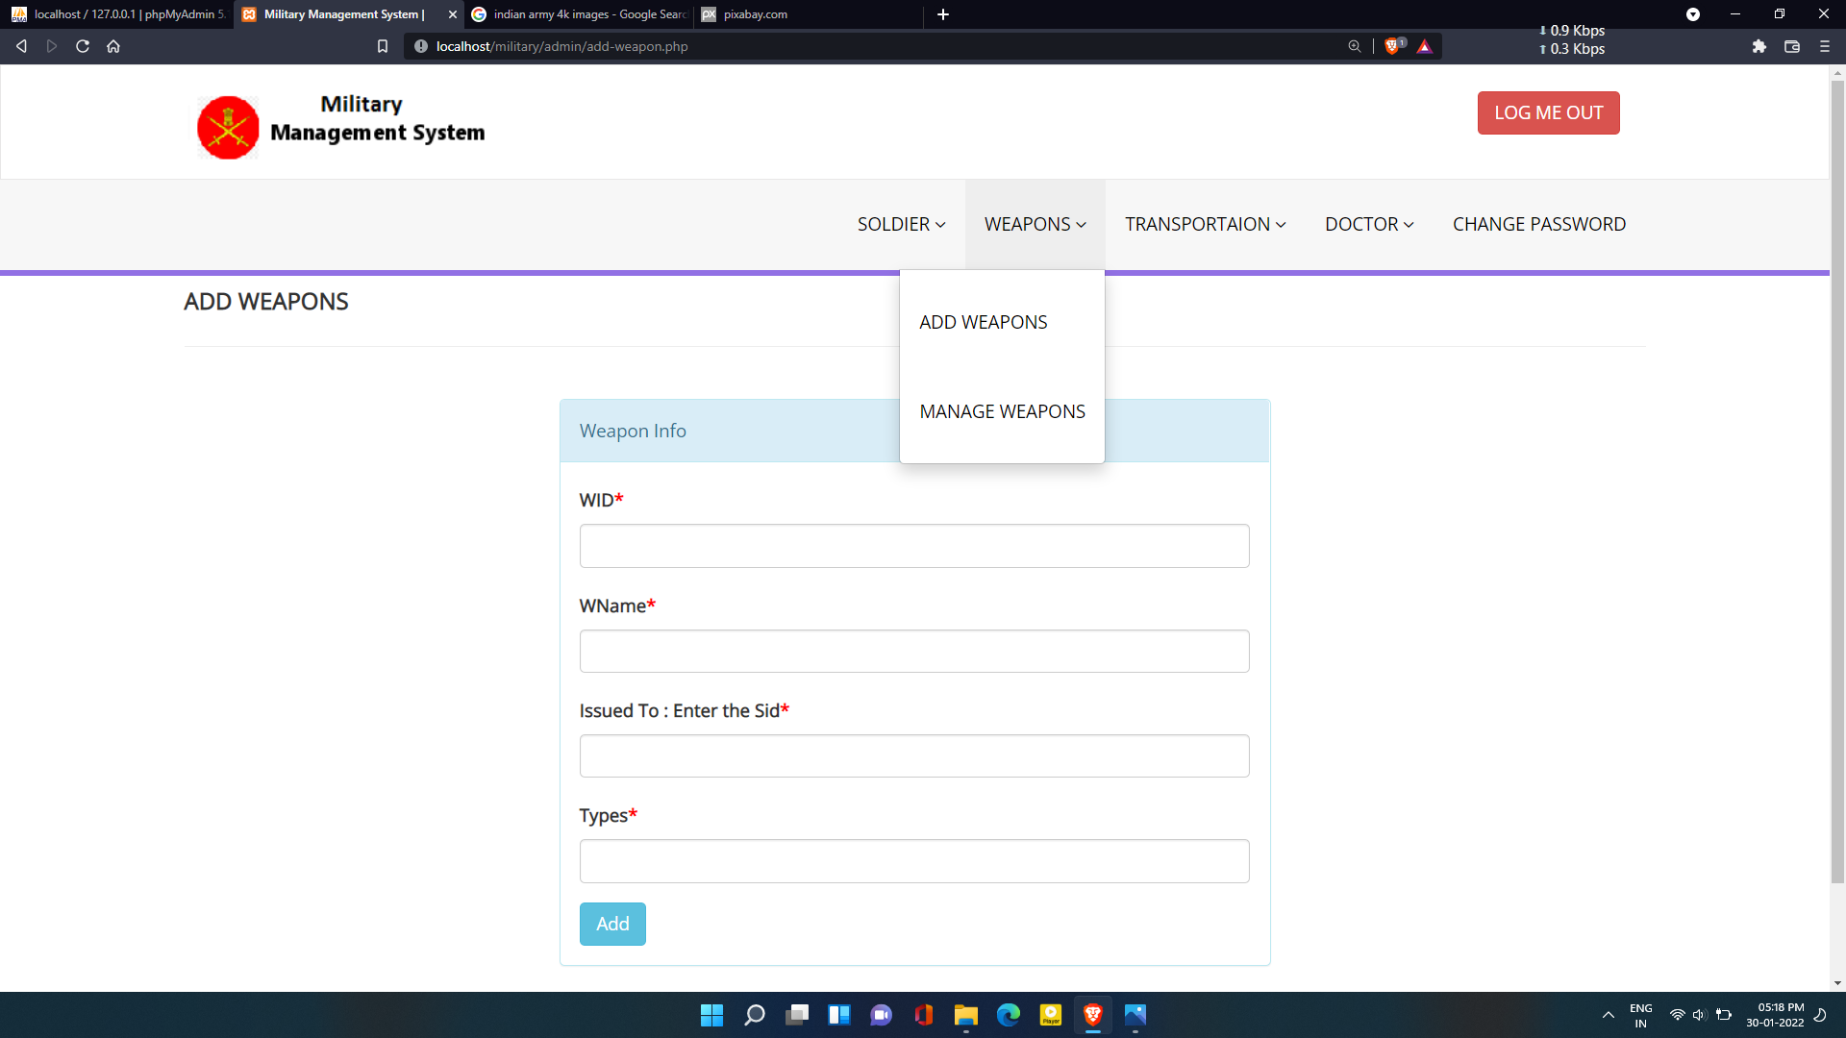
Fig 4.4: Add Weapons

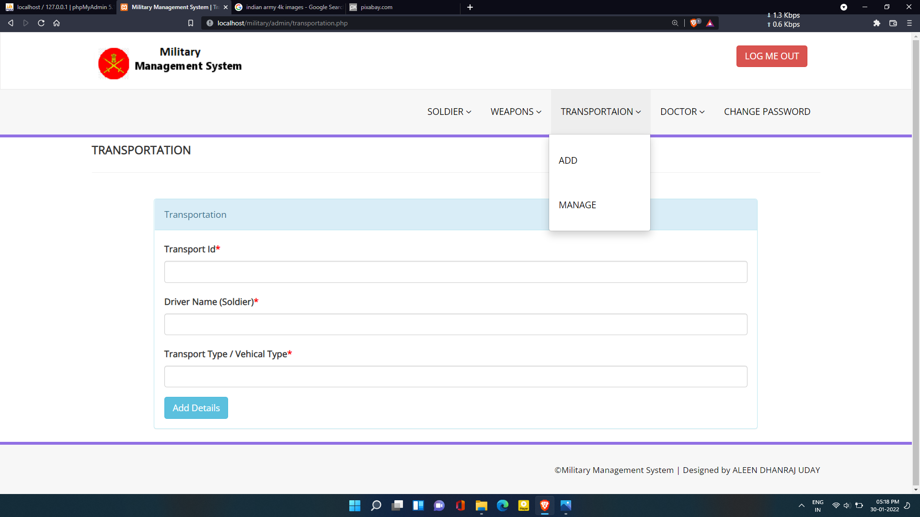
Fig 4.5: transportation

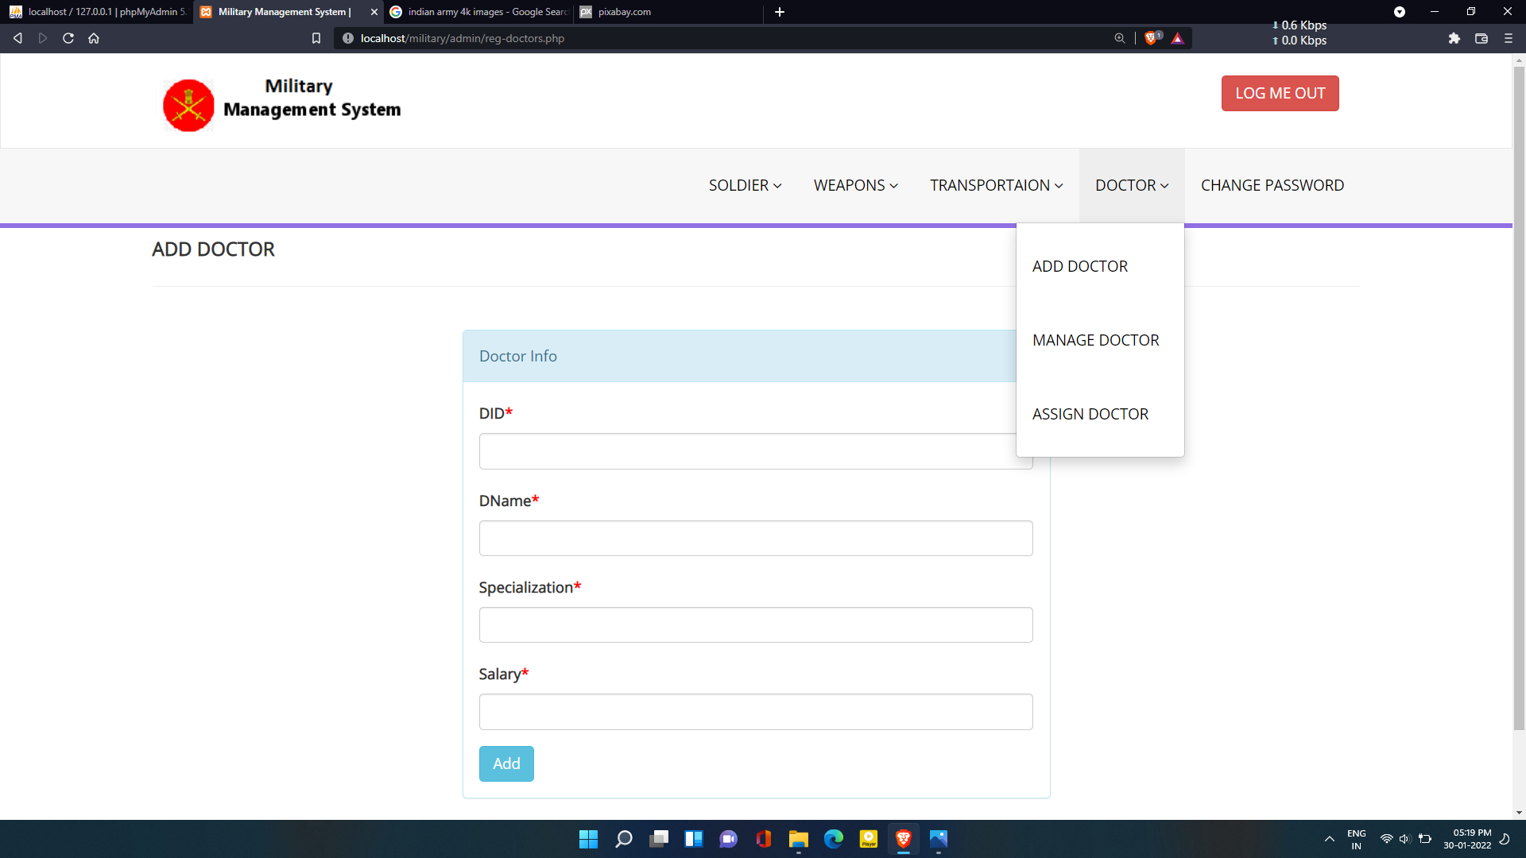
Fig 4.6: Add Doctors page

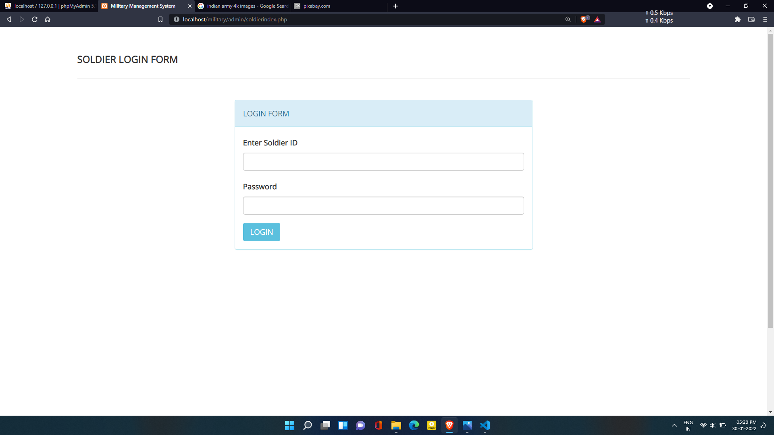

Fig 4.7: Add Soldiers Page

Conclusion and Future Enhancement

Conclusion
Military management system, allows the different modules to manage and store the details of the particular module and those details can be upgraded through admin and general public can also gather the basic information about the ministry.

Future Enhancement

1.In future we can add information about war memorials and we can also book tickets.

2.we can add information about war details.

References

Only include textbooks, not websites links
[1] Fundamentals of Database Management System by Pearson author Navathe 7th .
[2] PHP Pandas by Daylee rees.
[3] Learn to code HTML and CSS by shay Howe.
[4] Software engineering by Roger S. Pressman

